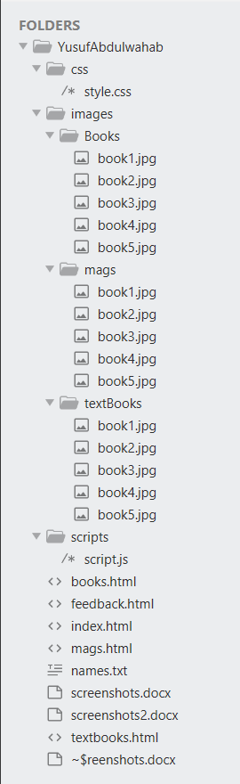**Directory structure**

**All the pages are responsive**

**Screen shots**

**Index.html**

Desktop view

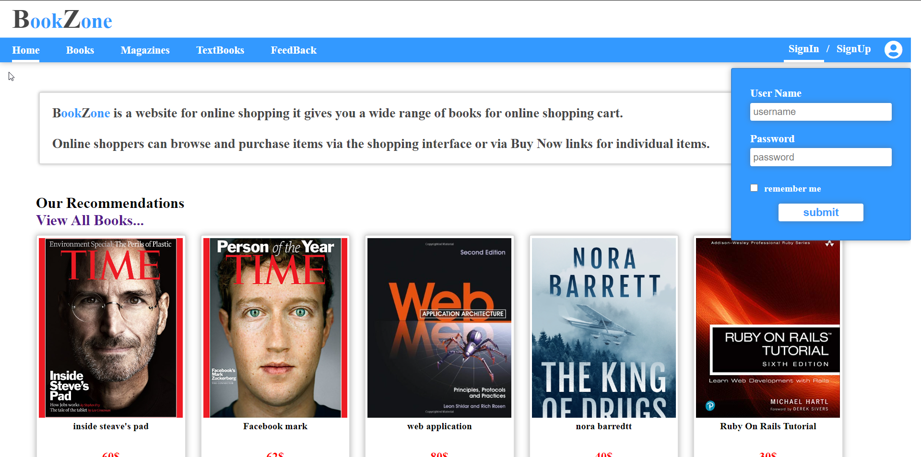

**books.html**

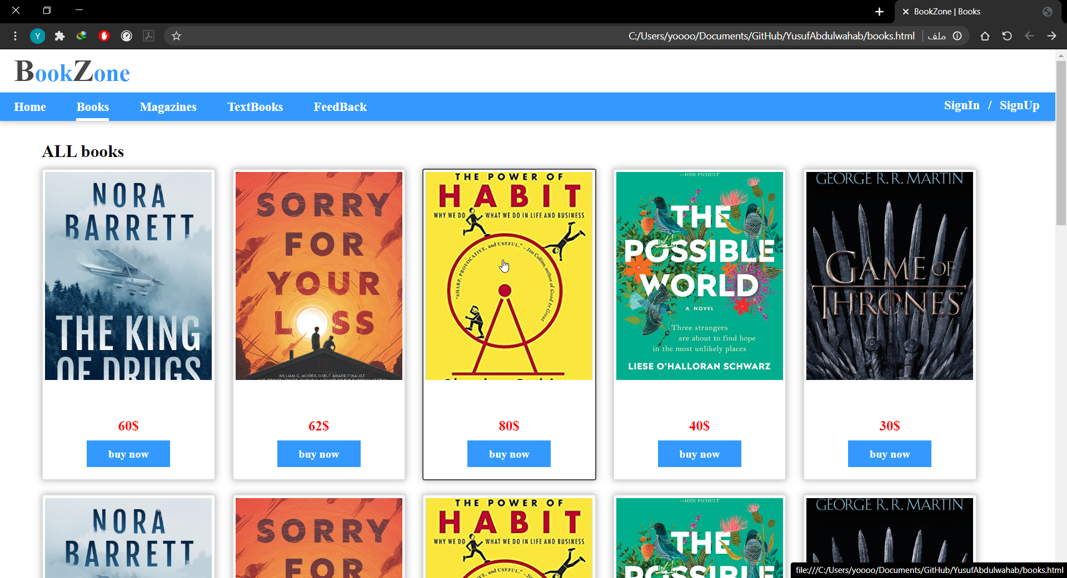

**mags.html**

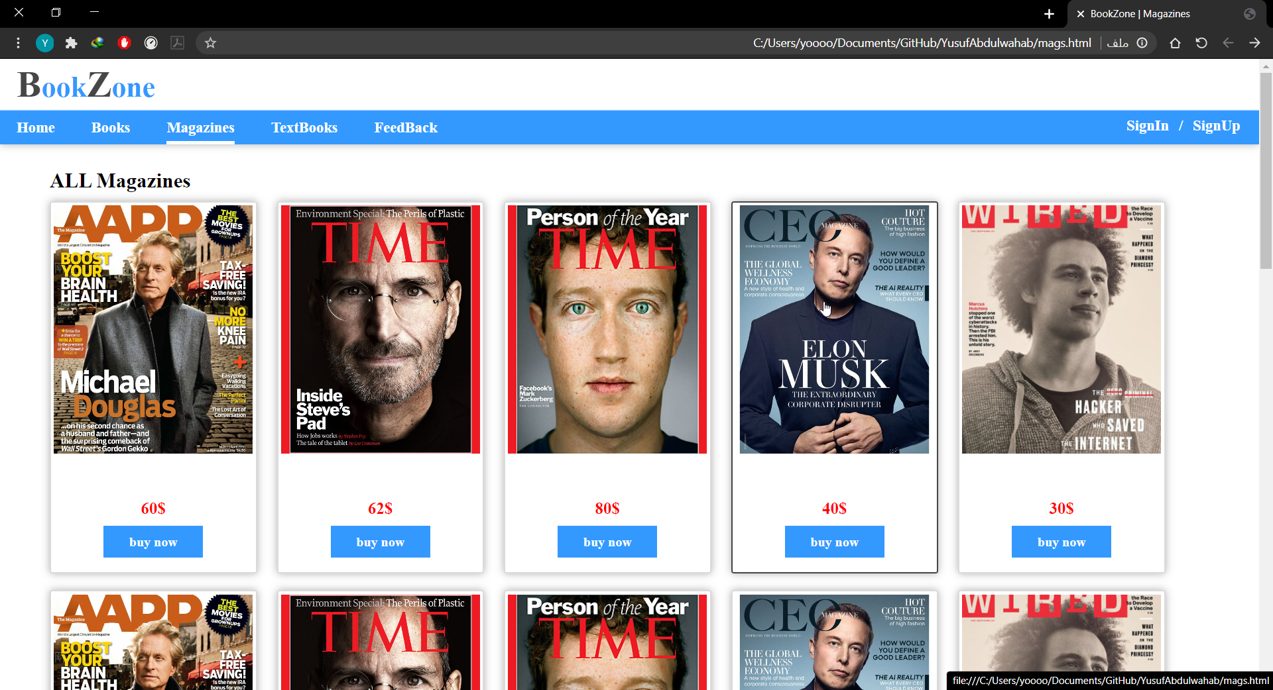

**textbooks.html**

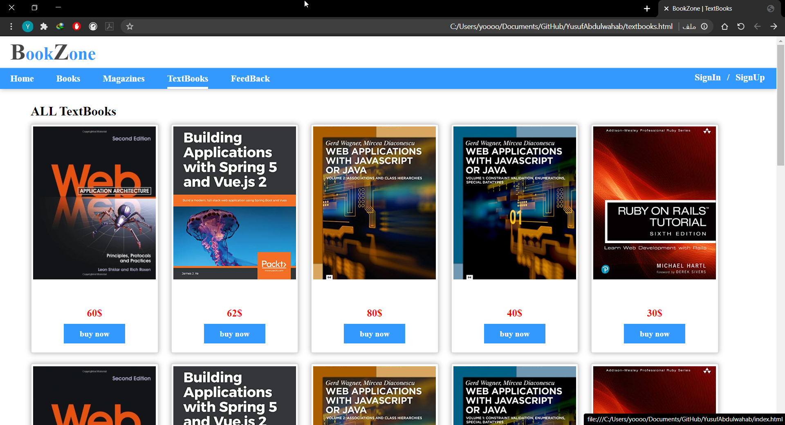

**feedback.html**

